<TITLE OF THESIS, DOUBLE SPACED AND CENTERED,
ALL UPPERCASE, INVERTED
PYRAMID FORM>

<STUDENT’S FULL OFFICIAL NAME, ALL UPPERCASE>
Maximizing Access to Research Careers Program (MARC)

APPROVED:
<Insert Mentor’s Name>, Ph.D., Research Mentor
Ricardo A. Bernal, Ph.D.
Skye Fortier, Ph.D.

<Insert Other Faculty Member Present>, Ph.D.

Keith Pannell, Ph.D.
Director, Maximizing Access to Research Careers Program

Copyright ©

by
<Student's Full Name>
<year>

HIDDEN TEXT: Optional—If you do not include a copyright page, delete entire page and the following page break.

Dedication

<OPTIONAL: Centered with no indent. If you do not include a Dedication, delete the entire page including the page break below>
<TITLE OF THESIS, DOUBLE SPACED AND CENTERED,
ALL UPPERCASE, INVERTED
PYRAMID FORM>

by

<STUDENT’S FULL OFFICIAL NAME, ALL UPPERCASE>

UNDERGRADUATE MARC THESIS

Presented to the Faculty of The University of Texas at El Paso
in Partial Fulfillment of the Requirements for the
MARC SCHOLARS PROGRAM
and the degree of
Bachelor of Science

Department of <Title of Academic Dept. or Program, Initial Capitals>
THE UNIVERSITY OF TEXAS AT EL PASO
<Month (May, August, or December)> <Year>

Acknowledgements
<OPTIONAL: If Acknowledgements page is not used, delete the entire page, including the following page break. Do not delete the section break at the end of the previous page (the title page). It is needed to initiate page numbering.>

Abstract
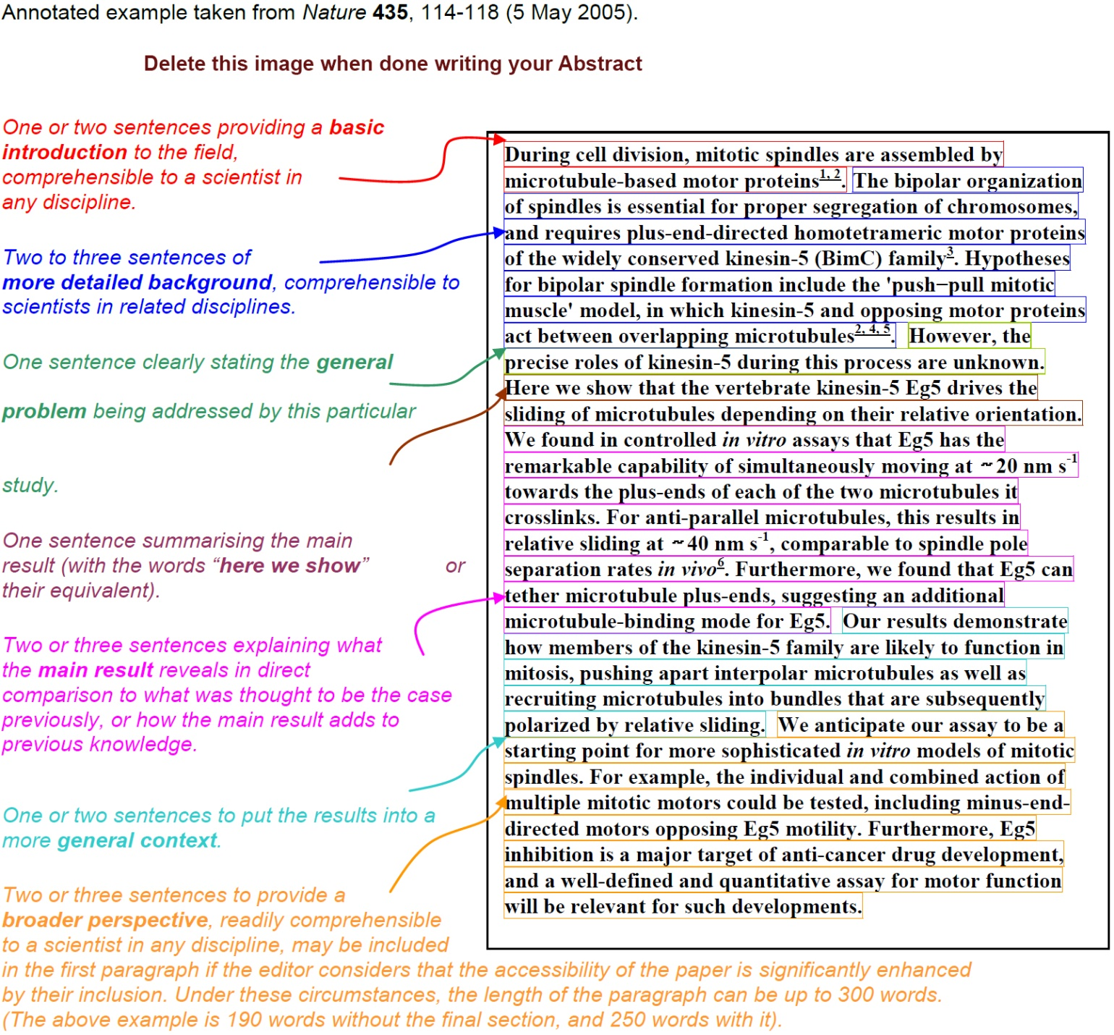
<The abstract can be as long as is needed to describe your project and results. The above example is meant as a lesson in writing a good abstract. Normally this should be 1-2 pages.>
< Do not change the contents of the Table of Contents and list of Tables and List of Figures on the next pages. Those are updated automatically from Headings in the body of the thesis. >

Table of Contents
Acknowledgements v
Abstract vi
Table of Contents vii
List of Tables viii
List of Figures viii
List of Illustrations viii
<Major Section - Heading 1,h1> 8
<Chapter 1: Chapter Title - Heading 2,h2> 8
1.1 This is an example section in chapter 1 - Heading 3,h3 8
<Chapter 2: Chapter Title - Heading 2,h2> 8
2.1 This is an example section in chapter2 - Heading 3,h3 8
2.2 This is a second section in chapter2 - Heading 3,h3 8
References 8
Glossary 8
Appendix 8
Vita…………….. 8

List of Tables
Table 1.1: Example of Heading 7,h7 format. 8

Table 2.1: Example of Heading 7,h7 format. 8

List of Figures
Figure 1.1: Example of Heading 8,h8 format. 8

Figure 2.1: Example of Heading 8,h8 format. 8

List of Illustrations
Illustration 1.1: Example of Heading 9,h9 format. 8

Illustration 2.1: Example of Heading 9,h9 format. 8

[IMPORTANT: Never delete the section break below. It is needed to initiate page numbering from the next page onwards. In case, you do not need a List of Illustrations page and you are deleting this page, make sure the section break is retained and goes to the end of the previous page. This text is for information only. Delete this text after reading.]

<Major Section - Heading 1,h1>
[Using Major Sections is optional and most theses don’t use them. If you do choose to use Major Sections instead of Chapters, make sure it is Heading1, H1 since this is needed to generate table of contents automatically.]

<Chapter 1: Chapter Title - Heading 2,h2>
<Body text to begin here. The following sample text and headings are for information only. Delete them after browsing.>
[Text,t: The first line of each paragraph is indented one-half inch, as shown, and the lines are justified, i.e., the right margin is even rather than ragged.
Paragraphs with the styles Heading 1,h1 or Heading 2,h2 applied can be extracted to appear in the table of contents with automatically. Use these styles ONLY for the respective headings and not for any other text in the document. Major Section: Heading1,h1 is an optional heading. Delete the entire paragraph if you do not use it.

1.1 This is an example section in chapter 1 - Heading 3,h3
Paragraphs with the style Heading 3,h3 applied can be extracted to appear in the table of contents as level 1 sub sections under the chapters.

1.1.1 A Subsection under Section 1.1 - Heading 4,h4
Paragraphs with the style Heading 4,h4 applied can be extracted to appear in the table of contents as level 2 subsections.

This is a Topic under section 1.1.1 - Heading 5,h5
Paragraphs with the style Heading 5,h5 applied can be extracted to appear in the table of contents as level 3 sub headings.

Another Topic under section 1.1.1 - Heading 5,h5
Paragraphs with the style Heading 5,h5 applied can be extracted to appear in the table of contents as level 3 sub headings.

Yet another Topic under section 1.1.1 - Heading 5,h5
Paragraphs with the style Heading 5,h5 applied can be extracted to appear in the table of contents as level 3 sub headings.

1.1.2 A Second Subsection under Section 1.1 - Heading 4,h4
Paragraphs with the style Heading 4,h4 applied can be extracted to appear in the table of contents as level 2 subsections.
Paragraphs with the style Heading 7,h7 applied can be extracted to appear in the list of tables. Remember that captions for tables are placed above the table. For all other material (figures, illustrations, maps, slides etc…), caption is placed below the illustration. Style Heading 7,h7 is used for naming tables, for example:

Table 1.1: Example of Heading 7,h7 format.
12 | 123 | 1234
23 | 234 | 2345

Paragraphs with the style Heading 8,h8 applied can be extracted to appear in the list of figures. Style Heading 8,h8 is used for naming figures , for example:

Figure 1.1: Example of Heading 8,h8 format.
Paragraphs with the style Heading 9,h9 applied can be extracted to appear in the list of illustrations. Style Heading 9,h9 is used for naming illustrations, for example:

Illustration 1.1: Example of Heading 9,h9 format.

<Chapter 2: Chapter Title - Heading 2,h2>
<Body text to begin here. The following sample text and headings are for information only. Delete them after browsing.>
[Text,t: The first line of each paragraph is indented one-half inch, as shown, and the lines are justified, i.e., the right margin is even rather than ragged.
Paragraphs with the styles Heading 1,h1 or Heading 2,h2 applied can be extracted to appear in the table of contents with automatically. Use these styles ONLY for the respective headings and not for any other text in the document. Major Section: Heading1,h1 is an optional heading. Delete the entire paragraph if you do not use it.

2.1 This is an example section in chapter2 - Heading 3,h3
Paragraphs with the style Heading 3,h3 applied can be extracted to appear in the table of contents as level 1 sub sections under the chapters.

2.1.1 A Subsection under Section 1.1 - Heading 4,h4
Paragraphs with the style Heading 4,h4 applied can be extracted to appear in the table of contents as level 2 subsections.

This is a Topic under section 2.1.1 - Heading 5,h5
Paragraphs with the style Heading 5,h5 applied can be extracted to appear in the table of contents as level 3 sub headings.

Another Topic under section 2.1.1 - Heading 5,h5
Paragraphs with the style Heading 5,h5 applied can be extracted to appear in the table of contents as level 3 sub headings.

Yet another Topic under section 2.1.1 - Heading 5,h5
Paragraphs with the style Heading 5,h5 applied can be extracted to appear in the table of contents as level 3 sub headings.

2.1.2 A Second Subsection under Section 2.1 - Heading 4,h4
Paragraphs with the style Heading 4,h4 applied can be extracted to appear in the table of contents as level 2 subsections.
Paragraphs with the style Heading 7,h7 applied can be extracted to appear in the list of tables. Remember that captions for tables are placed above the table. For all other material (figures, illustrations, maps, slides etc…), caption is placed below the illustration. Style Heading 7,h7 is used for naming tables, for example:

Table 2.1: Example of Heading 7,h7 format.
12 | 123 | 1234
23 | 234 | 2345

Paragraphs with the style Heading 8,h8 applied can be extracted to appear in the list of figures. Style Heading 8,h8 is used for naming figures , for example:

Figure 2.1: Example of Heading 8,h8 format.
Paragraphs with the style Heading 9,h9 applied can be extracted to appear in the list of illustrations. Style Heading 9,h9 is used for naming illustrations, for example:

Illustration 2.1: Example of Heading 9,h9 format.

2.2 This is a second section in chapter2 - Heading 3,h3
Paragraphs with the style Heading 3,h3 applied can be extracted to appear in the table of contents as level 1 sub sections under the chapters.

References
[This section may also be titled “References”, Works Cited”, or “Bibliography”.]
[Campbell, W. G. 1990. Form and Style in Thesis Writing, a Manual of Style. Chicago: The University of Chicago Press.]
[Turabian, K. L. 1987. A Manual for Writers of Term Papers, Theses, and Dissertations. 5th ed. Chicago: The University of Chicago Press.]

<It is highly recommended that you use the program called “ENDNOTES”. UTEP gives all students access to this.>
Glossary
<OPTIONAL: If Glossary not used, delete the entire page, including the following page break>

Appendix
<OPTIONAL: If Appendix not used, delete the entire page including the following page break>

Vita
<The vita is a brief biographical sketch of the writer written in paragraph format which provides information for future readers. It should include degrees awarded; publications and experience in teaching, business, and industry; military service, if any; and contact information. The vita should ideally be one page. The permanent address and name of the author should appear at the end of the page.>

Permanent address: <Street Name>
<City, State, Zip>

This thesis/dissertation was typed by <the author, or typist's name>.

This is a sample footnote.
This is a sample footnote.

